Initial Load Balancer Configuration

By Don Chen

# Description

Perform the initial configuration on a BIG-IP to have basic connection to the network, and activating the license.

# Requirements

* The BIG-IP Base Registration Key

# Step-by-Step Instructions

1. Plug into the console port of the F5, and access the CLI using a terminal emulation program.
2. Login with the default credentials: root/default.
3. It will prompt you to change the password. Type in the current password of “default”. Type in the new password of “qwe123$!” twice. It will do a short restart. Your screen should look like the screenshot below.

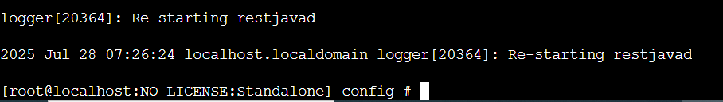

1. Type “config” into the CLI.

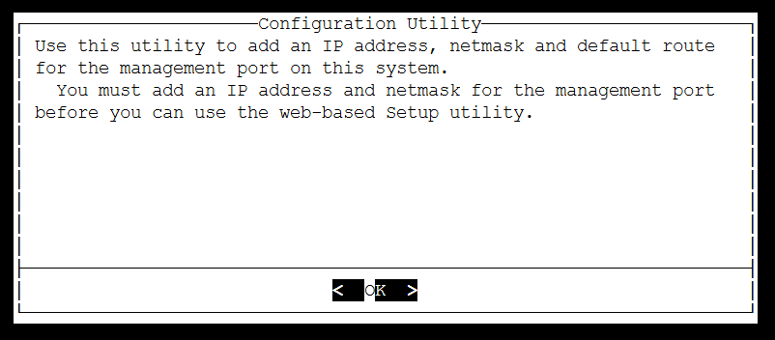

1. Press enter to start. Press enter again to select IPv4. Select no on “Use automatic configuration of IP address. Change the IP address to 10.101.0.76. Change the Netmask” to 255.255.255.0. Select Yes on “Management Route”. Change the “Management Route” to 10.101.0.1. Ensure that your “Confirm Configuration” screen looks like below. Click yes.

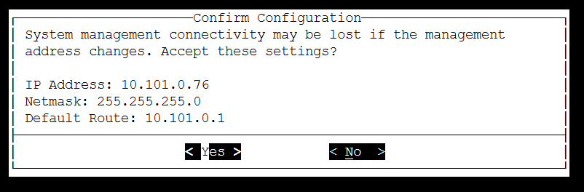

1. Access a computer on the same subnet of 10.101.0.0/24.
2. Open a browser and access <https://10.101.0.76>
3. Ignore the warning and proceed. You will see a screen similar to below.

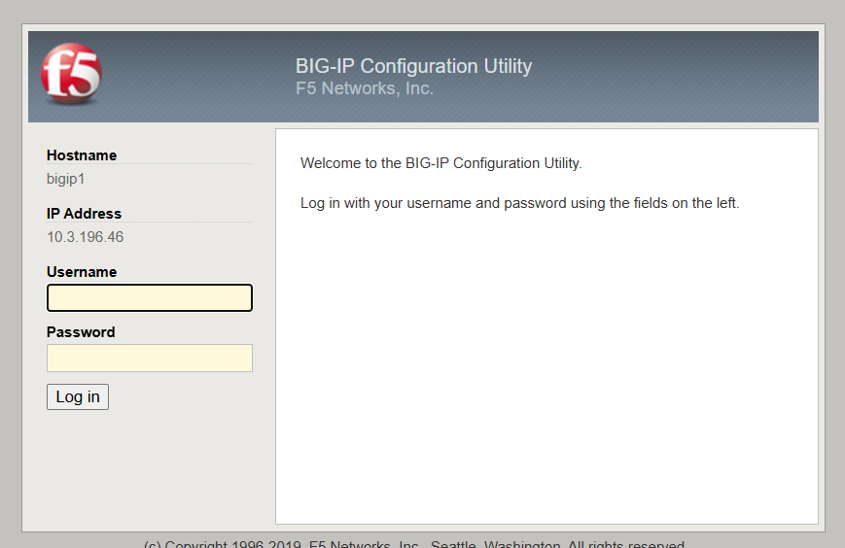

1. Login with admin/hgown))). You will then see a screen like below.

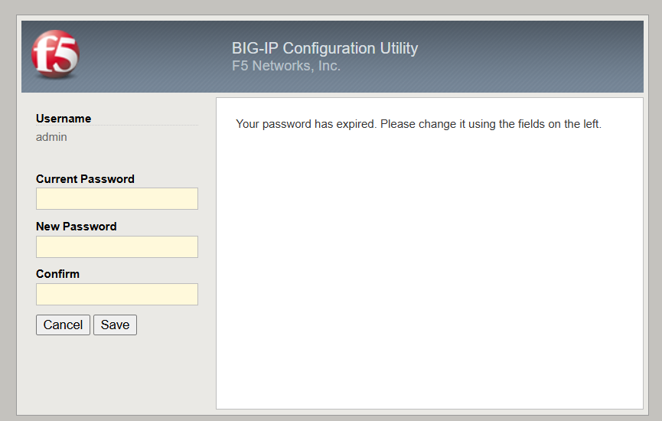

1. Type “qwe123$!” into all of the fields and click save. You will be back at the login screen.
2. Login in with admin/hgown))). You will be met with the setup utilility.

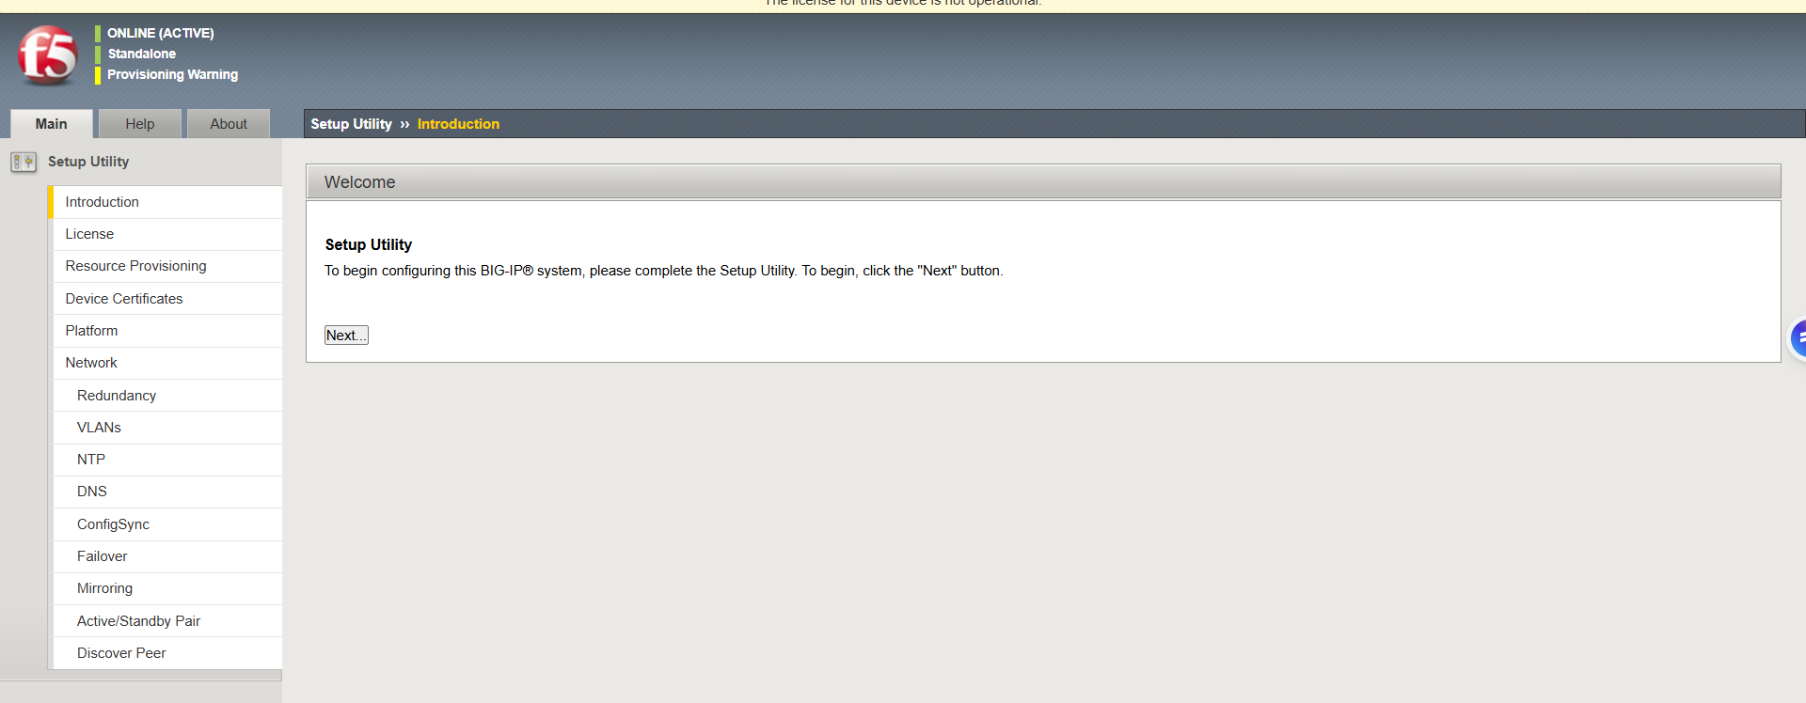

1. Click Next. Click Activate.

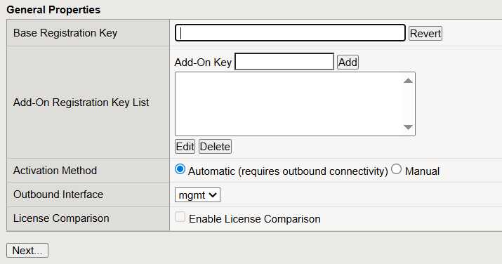

1. Paste your Base Registration Key into “Base Registration Key”. Then click Next.

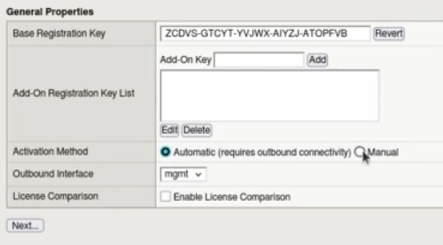

1. It will give you a Dossier. Copy it, and then click the link below to access the F5 licensing server.

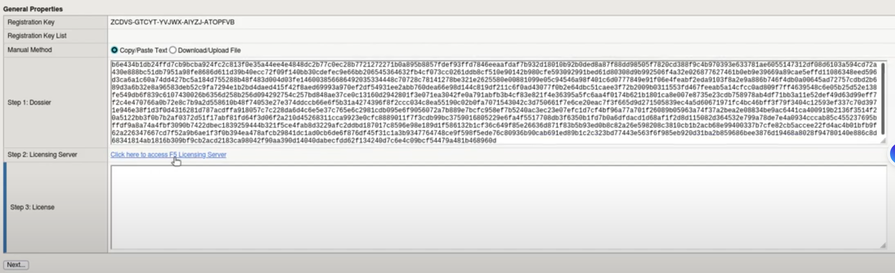

1. Paste your Dossier into the text box and click next. This page shows the new license key. Copy it.
2. Go back to your F5 GUI, paste the license key into “Step 3: License” and click next.

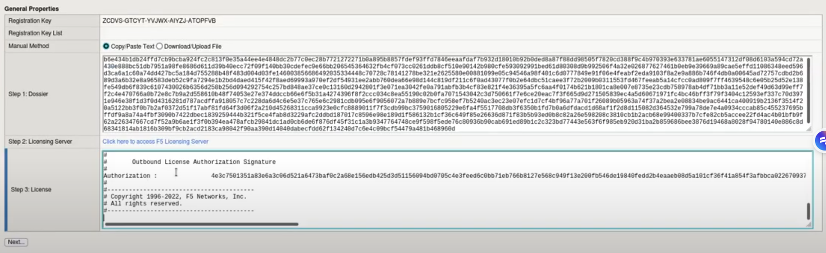

1. In the top left of your screen, you will see “ONLINE(ACTIVE)” and “Standalone” like the image below.

